MODERN DATABASE SYSTEMS LAB 7

RETAIL SALES ANALYTICS PART3

NAME: PAVITHIRAN.V ROLL NO: 235229122

SELECT st.TYPE, AVG(s.WEEKLY_SALES) AS AVG_WEEKLY_SALES

FROM sales_data s

JOIN stores_data st ON s.STORE_ID = st.STORE_ID

GROUP BY st.TYPE;

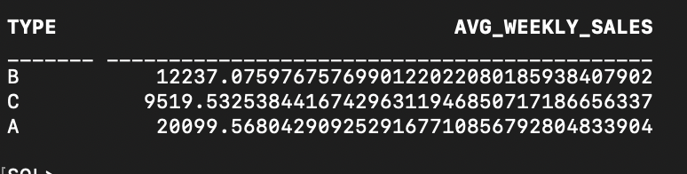

SELECT st.TYPE, f.DATE1, MAX(f.TEMPERATURE) AS MAX_TEMPERATURE

FROM features_data f

JOIN stores_data st ON f.STORE_ID = st.STORE_ID

WHERE f.DATE1 > '05-02-2010'

GROUP BY st.TYPE, f.DATE1

Fetch first 5 rows only;

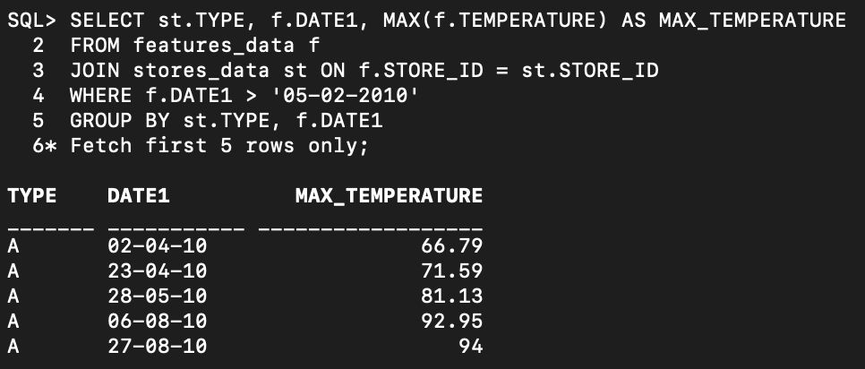

SELECT st.TYPE, SUM(s.WEEKLY_SALES) AS TOTAL_WEEKLY_SALES

FROM sales_data s

JOIN stores_data st ON s.STORE_ID = st.STORE_ID

GROUP BY st.TYPE

HAVING MIN(st.SIZE1) >= 3000;

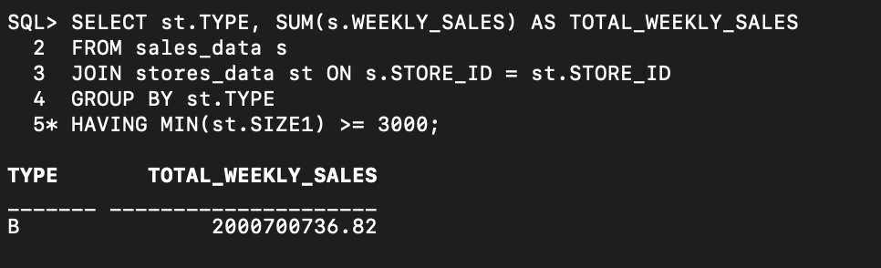

SELECT s.DEPT, COUNT(*) AS HOLIDAY_COUNT

FROM sales_data s

JOIN features_data f ON s.STORE_ID = f.STORE_ID

WHERE f.CPI > 220

GROUP BY s.DEPT

HAVING COUNT(*) > 2

Fetch first 5 rows only;

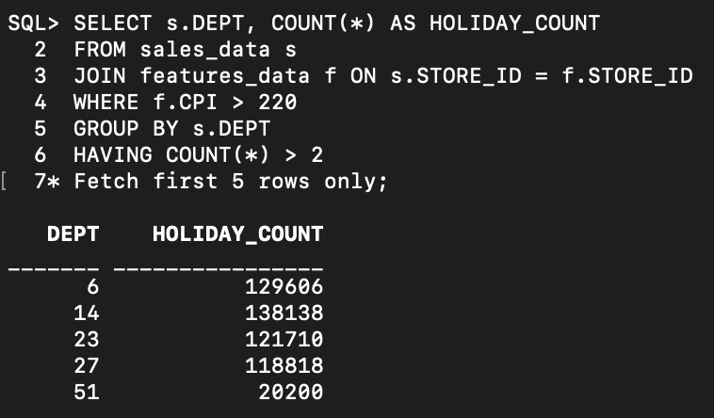

SELECT st.TYPE, AVG(f.MARKDOWN1) AS AVG_MARKDOWN1, MAX(f.MARKDOWN2) AS MAX_MARKDOWN2

FROM features_data f

JOIN stores_data st ON f.STORE_ID = st.STORE_ID

GROUP BY st.TYPE;

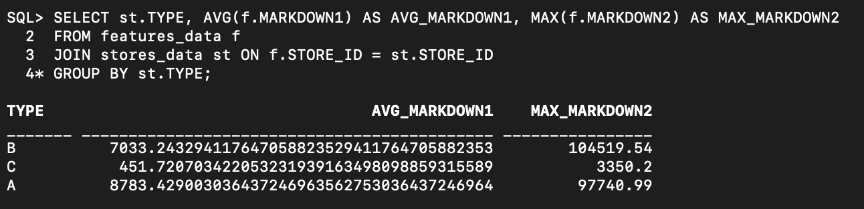

SELECT st.TYPE, AVG(f.UNEMPLOYMENT) AS AVG_UNEMPLOYMENT

FROM features_data f

JOIN stores_data st ON f.STORE_ID = st.STORE_ID

GROUP BY st.TYPE

HAVING AVG(f.UNEMPLOYMENT) > 7.5;

